Smith and Wesson SD9VE/SD40VE M.R.A. (Modular Red Dot Adapter) Mounting Instructions
• While it is possible to install this mount without the use of a Gun Smith, we recommend using a certified Gun Smith for Installation

WARNING: Never remove or install components on a gun without ensuring the gun is not loaded and the chamber is clear.
Step 1: Remove existing rear sight from slide
Step 2: Install OUTERIMPACT dovetail onto slide. Dovetail and dovetail screws are located in bag marked “DVT.”
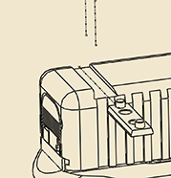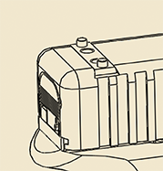
Step 3: Test fit the Red Dot sight to Outerimpact adapter, utilizing red dot pattern installation chart. Note: Make sure screws do not stick out beyond bottom of adapter. After test fitting, remove Red Dot sight from adapter.
Step 4: Secure sight adapter to dovetail with supplied weaver screws. Torque to 25 in/lb. We recommend applying blue thread locker to all threads upon final installation.
